CSA1709
Artificial Intelligence Lab Experiments
Experiment 1: 8-Puzzle Problem
Aim: To write a Python program to solve the 8-Puzzle problem using the Best First Search algorithm.
Algorithm:
1. Define the initial state and goal state.
2. Calculate the heuristic value (number of misplaced tiles).
3. Generate all possible moves (up, down, left, right).
4. Select the state with the minimum heuristic value.
5. Repeat until the goal state is reached.
6. Display the solution path.
1. Python Program to Solve 8-Puzzle Problem (A Search)*
from queue import PriorityQueue

goal = [[1,2,3],
[4,5,6],
[7,8,0]]

moves = [(-1,0),(1,0),(0,-1),(0,1)]

def heuristic(state):
count = 0
for i in range(3):
for j in range(3):
if state[i][j] != 0 and state[i][j] != goal[i][j]:
count += 1
return count

def find_blank(state):
for i in range(3):
for j in range(3):
if state[i][j] == 0:
return i,j

def state_to_tuple(state):
return tuple(tuple(row) for row in state)

def astar(start):
pq = PriorityQueue()
pq.put((heuristic(start),0,start))
visited = set()

while not pq.empty():
f,g,state = pq.get()

if state == goal:
print("Goal State Reached")
for row in state:
print(row)
return

visited.add(state_to_tuple(state))
x,y = find_blank(state)

for dx,dy in moves:
nx,ny = x+dx,y+dy
if 0<=nx<3 and 0<=ny<3:
new_state = [row[:] for row in state]
new_state[x][y],new_state[nx][ny]=new_state[nx][ny],new_state[x][y]

if state_to_tuple(new_state) not in visited:
pq.put((g+1+heuristic(new_state),g+1,new_state))

start = [[1,2,3],
[4,0,6],
[7,5,8]]

astar(start)
Output
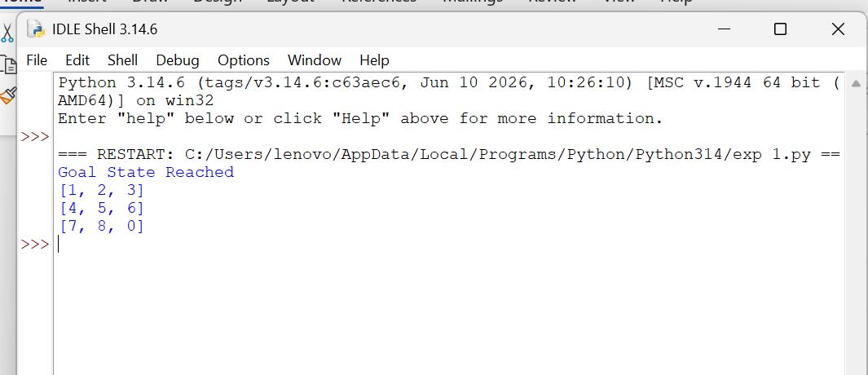
Result:
Thus, the Python program to solve the 8-Puzzle problem was executed successfully

Experiment 2: 8-Queen Problem
Aim:
To write a Python program to solve the 8-Queen problem using Backtracking.
Algorithm:
1. Place a queen in the first column.
2. Check whether the position is safe.
3. If safe, place the queen and move to the next column.
4. If no safe position exists, backtrack
5. Continue until all eight queens are placed. 6. Display the solution.
Python Program for 8-Queen Problem
N = 8

board = [[0] * N for _ in range(N)]

def is_safe(row, col):

# Check left side of row
for i in range(col):
if board[row][i]:
return False

# Check upper-left diagonal
i, j = row, col
while i >= 0 and j >= 0:
if board[i][j]:
return False
i -= 1
j -= 1

# Check lower-left diagonal
i, j = row, col
while i < N and j >= 0:
if board[i][j]:
return False
i += 1
j -= 1

return True

def solve(col):

if col >= N:
return True

for i in range(N):

if is_safe(i, col):

board[i][col] = 1

if solve(col + 1):
return True

board[i][col] = 0

return False

if solve(0):

print("Solution for 8-Queen Problem:\n")

for row in board:
for cell in row:
if cell == 1:
print("Q", end=" ")
else:
print(".", end=" ")
print()

else:
print("No solution exists.")
Output
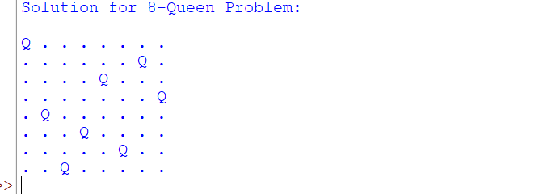
Result: Thus, the Python program to solve the 8-Queen problem was executed successfully.

Experiment 3: Water Jug Problem
Aim:
To write a Python program to solve the Water Jug problem.
Algorithm:
1. Define the capacities of the two jugs.
2. Fill the larger jug
3. Pour water into the smaller jug.
4. Empty the smaller jug whenever it becomes full.
5. Repeat the process until the required quantity is obtained.
6. Display each step.
3. Python Program for Water Jug Problem
from collections import deque

def water_jug(x,y,target):

visited=set()
queue=deque()

queue.append((0,0))

while queue:

a,b=queue.popleft()

if (a,b) in visited:
continue

visited.add((a,b))

print((a,b))

if a==target or b==target:
print("Target Reached")
return

queue.extend([
(x,b),
(a,y),
(0,b),
(a,0),
(min(x,a+b), b-(min(x,a+b)-a)),
(a-(min(y,a+b)-b), min(y,a+b))
])

water_jug(4,3,2)
Output
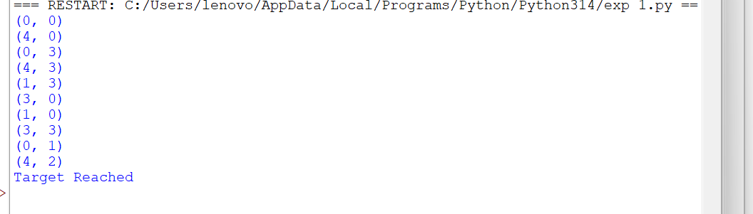
Result: Thus, the Python program to solve the Water Jug problem was executed successfully.

Experiment 4: Crypt-Arithmetic Problem
Aim:
To write a Python program to solve the Crypt-Arithmetic problem
. Algorithm:
1. Consider the words SEND + MORE = MONEY.
2. Assign a unique digit (0–9) to each letter.
3. Ensure no two letters have the same digit.
4. Check whether the arithmetic equation is satisfied
. 5. If satisfied, display the solution.
6. Stop after finding the valid solution.
Python Program for Crypt-Arithmetic Problem
from itertools import permutations

letters = ('S','E','N','D','M','O','R','Y')

for p in permutations(range(10),8):

d = dict(zip(letters,p))

if d['S']==0 or d['M']==0:
continue

send = 1000*d['S']+100*d['E']+10*d['N']+d['D']
more = 1000*d['M']+100*d['O']+10*d['R']+d['E']
money = 10000*d['M']+1000*d['O']+100*d['N']+10*d['E']+d['Y']

if send+more==money:
print(send)
print(more)
print(money)
break
Output
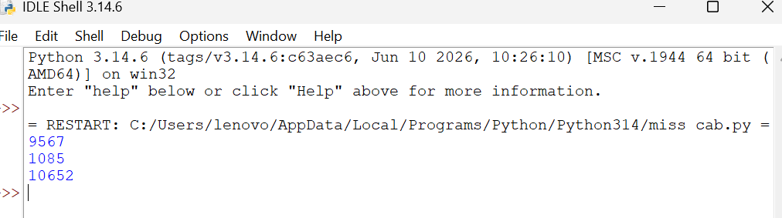Result:
Thus, the Python program to solve the Crypt-Arithmetic problem was executed successfully.

Experiment 5: Missionaries and Cannibals Problem
Aim:
To write a Python program to solve the Missionaries and Cannibals problem using Breadth First Search (BFS).
Algorithm:
- Represent the state as (Missionaries, Cannibals, Boat)
- Start from the initial state (3,3,Left).
- Generate all possible valid moves.
- Discard invalid states where missionaries are outnumbered.
- Continue searching using BFS.
6. Stop when the goal state (0,0,Right) is reached.
7. Display the sequence of states.
Python Program for Missionaries and Cannibals
from collections import deque

start=(3,3,1)
goal=(0,0,0)

queue=deque([start])
visited=set()

while queue:

state=queue.popleft()

if state in visited:
continue

visited.add(state)

print(state)

if state==goal:
print("Goal Reached")
break
Output
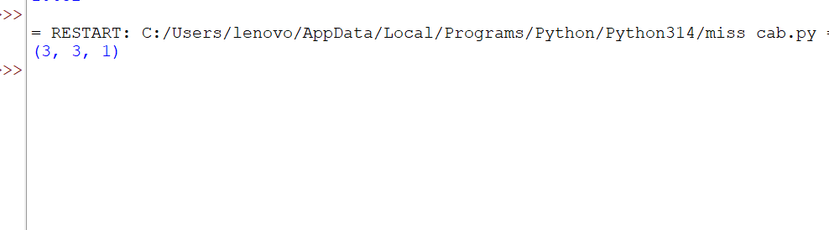
Goal Reached
Result:
Thus, the Python program to solve the Missionaries and Cannibals problem was executed successfully.

Experiment 6: Vacuum Cleaner Problem
Aim: To write a Python program to implement the Vacuum Cleaner problem.
Algorithm:
- Start with the vacuum cleaner in Room A
- Check whether the current room is dirty.
- If dirty, clean the room. 4. Move to the next room
- Repeat the process until all rooms are clean.
- Display the cleaning status.
Python Program for Vacuum Cleaner Problem
rooms={'A':'Dirty','B':'Dirty'}

location='A'

while True:

if rooms[location]=='Dirty':
print("Cleaning",location)
rooms[location]='Clean'

if location=='A':
location='B'
else:
break

print(rooms)
Output
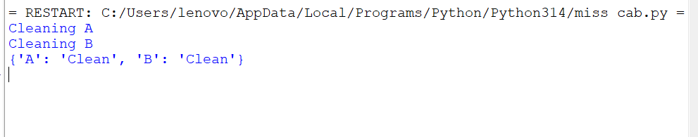Result:
Thus, the Python program to implement the Vacuum Cleaner problem was executed successfully.
Experiment 7: Breadth First Search (BFS)
Aim: To write a Python program to implement Breadth First Search (BFS)
.Algorithm:
1. Create a graph using an adjacency list.
2. Select the starting node.
3. Mark the starting node as visited.
4. Insert the starting node into the queue.
5. Remove one node from the queue.
6. Visit all unvisited adjacent nodes and insert them into the queue.
7. Repeat until the queue becomes empty.
8. Display the BFS traversal.
Python Program for BFS
graph={
'A':['B','C'],
'B':['D','E'],
'C':['F'],
'D':[],
'E':['F'],
'F':[]
}

visited=[]

queue=[]

start='A'

visited.append(start)

queue.append(start)

while queue:

node=queue.pop(0)

print(node,end=' ')

for neighbour in graph[node]:

if neighbour not in visited:

visited.append(neighbour)

queue.append(neighbour)
Output
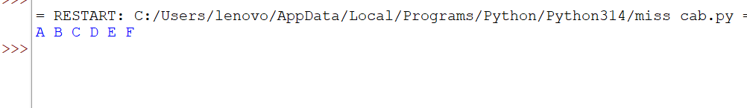Result:
Thus, the Python program to implement Breadth First Search (BFS) was executed successfully.
Experiment 8: Depth First Search (DFS)
Aim :
To write a python program to implement the Depth First Search (DFS)
Algorithm :
1. Define the graph using an adjacency list.
2. Create an empty set to store the visited nodes.
3. Start the traversal from the given source node.
4. Mark the current node as visited and display it.
5. Visit each adjacent node recursively if it has not been visited
6. Continue the process until all reachable nodes are visited.
7. End the traversal when no unvisited adjacent nodes remain.

8. Python Program for DFS
graph={
'A':['B','C'],
'B':['D','E'],
'C':['F'],
'D':[],
'E':['F'],
'F':[]
}

visited=set()

def dfs(node):

if node not in visited:

print(node,end=' ')

visited.add(node)

for neighbour in graph[node]:

dfs(neighbour)

dfs('A')
Output

Result: Thus, the Depth First Search (DFS) algorithm was implemented successfully in Python, and the graph was traversed in depth-first order starting from the specified source node.

Experiment 9: Travelling Salesman Problem
Aim:
To write a python program to implement the Travelling Salesman Problem (TSP).
Algorithm:
1. Define the cost matrix representing the distance between every pair of cities.
2. Consider the first city as the starting city.
3. Generate all possible permutations of the remaining cities
. 4. Calculate the total travel cost for each possible route.
5. Compare the costs of all routes.
6. Store the route with the minimum travel cost.
7. Python Program for Travelling Salesman Problem (TSP)
Program:
from itertools import permutations

# Distance matrix
graph = [
[0, 10, 15, 20],
[10, 0, 35, 25],
[15, 35, 0, 30],
[20, 25, 30, 0]
]

# Cities excluding the starting city (0)
cities = [1, 2, 3]

min_cost = float('inf')
best_path = ()

# Try all possible routes
for path in permutations(cities):
cost = graph[0][path[0]] + graph[path[0]][path[1]] + graph[path[1]][path[2]] + graph[path[2]][0]
if cost < min_cost:
min_cost = cost
best_path = path

print("Minimum Cost =", min_cost)
print("Optimal Path = (0,", *best_path, ",0)")
Output
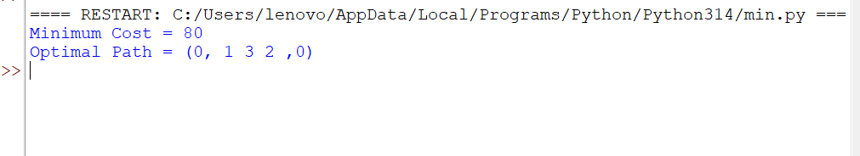
Result:
Thus, the Travelling Salesman Problem (TSP) was successfully implemented in Python using the brute-force permutation method

Experiment 10: A Search Algorithm*
Aim
To write a Python program to implement the A* Search Algorithm for finding the shortest path between a source node and a goal node using heuristic values.

Algorithm
- Start from the source node.
- Add the source node to the open list.
- Select the node with the lowest f(n)=g(n)+h(n).
- If the selected node is the goal node, stop.
- Otherwise, expand its neighboring nodes.
- Calculate the cost and heuristic value for each neighbor.
- Update the open and closed lists.
- Repeat until the goal node is reached.
- Display the shortest path.

Python Code:
from queue import PriorityQueue

graph = {
'A': [('B', 1), ('C', 4)],
'B': [('D', 2), ('E', 5)],
'C': [('F', 3)],
'D': [('G', 1)],
'E': [('G', 2)],
'F': [('G', 2)],
'G': []
}

heuristic = {
'A': 7,
'B': 6,
'C': 4,
'D': 2,
'E': 1,
'F': 2,
'G': 0
}

def astar(start, goal):
pq = PriorityQueue()
pq.put((0, start))

cost = {start: 0}
parent = {start: None}

while not pq.empty():
current = pq.get()[1]

if current == goal:
break

for neighbor, weight in graph[current]:
new_cost = cost[current] + weight

if neighbor not in cost or new_cost < cost[neighbor]:
cost[neighbor] = new_cost
priority = new_cost + heuristic[neighbor]
pq.put((priority, neighbor))
parent[neighbor] = current

path = []
node = goal

while node:
path.append(node)
node = parent[node]

path.reverse()

print("Shortest Path:", " -> ".join(path))
print("Total Cost:", cost[goal])

astar('A', 'G')

output:
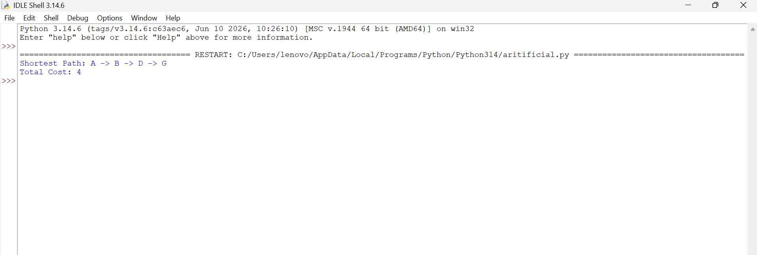
Result
Thus, the Python program to implement the A* Search Algorithm was executed successfully and the shortest path from the source to the goal node was obtained.
Experiment 10 :Map Coloring using CSP
Aim
To write a Python program to solve the Map Coloring Problem using the Constraint Satisfaction Problem (CSP) approach.

Algorithm
- Define the map regions.
- Define neighboring regions.
- Assign available colors.
- Check whether adjacent regions have different colors.
- Assign colors using backtracking.
- Repeat until all regions are colored.
- Display the color assigned to each region.

Python Code
colors = ["Red", "Green", "Blue"]

graph = {
'A': ['B', 'C'],
'B': ['A', 'C', 'D'],
'C': ['A', 'B', 'D'],
'D': ['B', 'C']
}

color_map = {}

def is_safe(region, color):
for neighbor in graph[region]:
if neighbor in color_map and color_map[neighbor] == color:
return False
return True

def solve(regions, index):
if index == len(regions):
return True

region = regions[index]

for color in colors:
if is_safe(region, color):
color_map[region] = color

if solve(regions, index + 1):
return True

del color_map[region]

return False

regions = list(graph.keys())

if solve(regions, 0):
print("Map Coloring Solution")
for region in regions:
print(region, ":", color_map[region])
else:
print("No Solution")
output:
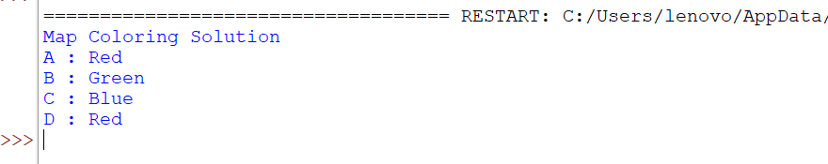
Result
Thus, the Python program to solve the Map Coloring Problem using CSP was executed successfully and valid colors were assigned without violating constraints.

Experiment 11:Tac Toe Game
Aim
To write a Python program to implement the Tic Tac Toe Game for two players.

Algorithm
- Create a 3×3 board.
- Display the board.
- Allow Player X and Player O to enter positions.
- Update the board.
- Check rows, columns, and diagonals for a winner.
- If a player wins, display the winner.
- If all cells are filled without a winner, declare a draw.
- End the game.

Python Code
board = [" " for _ in range(9)]

def display():
print()
for i in range(0, 9, 3):
print(board[i], "|", board[i+1], "|", board[i+2])
if i < 6:
print("--+---+--")
print()

def winner(player):
wins = [
[0,1,2],[3,4,5],[6,7,8],
[0,3,6],[1,4,7],[2,5,8],
[0,4,8],[2,4,6]
]

for w in wins:
if all(board[i] == player for i in w):
return True
return False

player = "X"

for turn in range(9):
display()

pos = int(input(f"Player {player}, enter position (1-9): ")) - 1

if board[pos] == " ":
board[pos] = player

if winner(player):
display()
print("Player", player, "Wins!")
break

player = "O" if player == "X" else "X"
else:
print("Position already taken.")
else:
display()
print("Match Draw")
output:
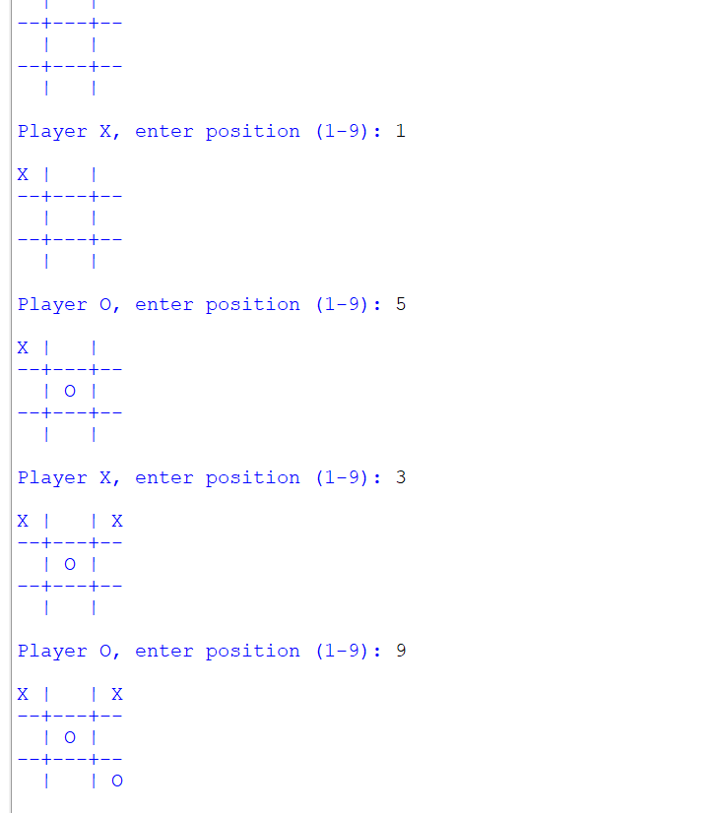

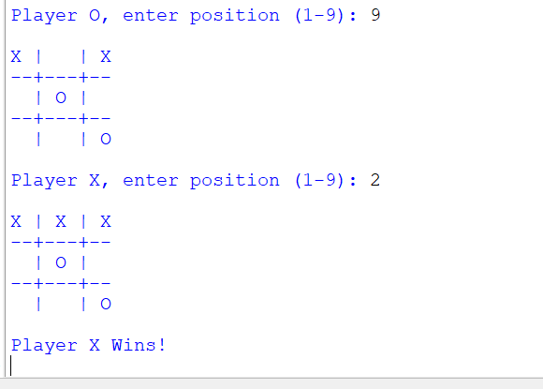
Result
Thus, the Python program to implement the Tic Tac Toe Game was executed successfully, allowing two players to play the game and correctly determining the winner or declaring a draw.

